**AI LAB EXP-4**

**IMPLEMENTATION OF DFS AND BFS**

**Date: 08-02-2022**

**Name: Vakada Siva Supradeep**

**Reg No: RA1911030010104**

**Github link:**

**AIM:** To implement BFS(Breadth First Search) and DFS(Depth First Search) using Python.

**DFS CODE:**

graph={

'A':['B','C'],

'B':['D'],

'C':['F'],

'D':['E','F'],

'E':[],

'F':['A']

}

visited=set()

def dfs(visited,graph,node):

if node not in visited:

print(node)

visited.add(node)

for neighbour in graph[node]:

dfs(visited,graph,neighbour)

dfs(visited,graph,'A')

**OUTPUT SCREENSHOT:**

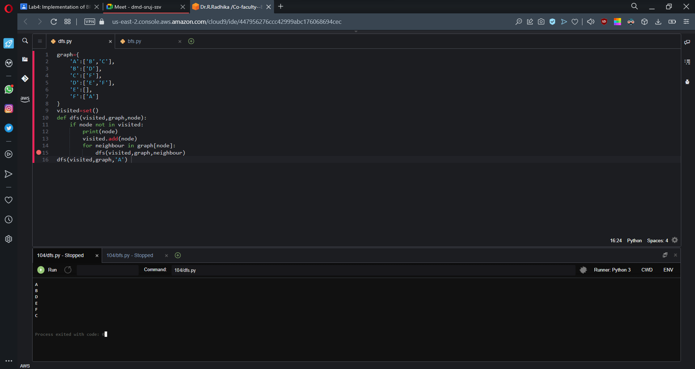

**BFS CODE:**

graph = {

'5' : ['3','7'],

'3' : ['2', '4'],

'7' : ['8'],

'2' : [],

'4' : ['8'],

'8' : []

}

visited = []

queue = []

def bfs(visited, graph, node):

visited.append(node)

queue.append(node)

while queue:

m = queue.pop(0)

print (m, end = " ")

for neighbour in graph[m]:

if neighbour not in visited:

visited.append(neighbour)

queue.append(neighbour)

# Driver Code

print("Following is the Breadth-First Search")

bfs(visited, graph, '5')

**OUTPUT SCREENSHOT:**

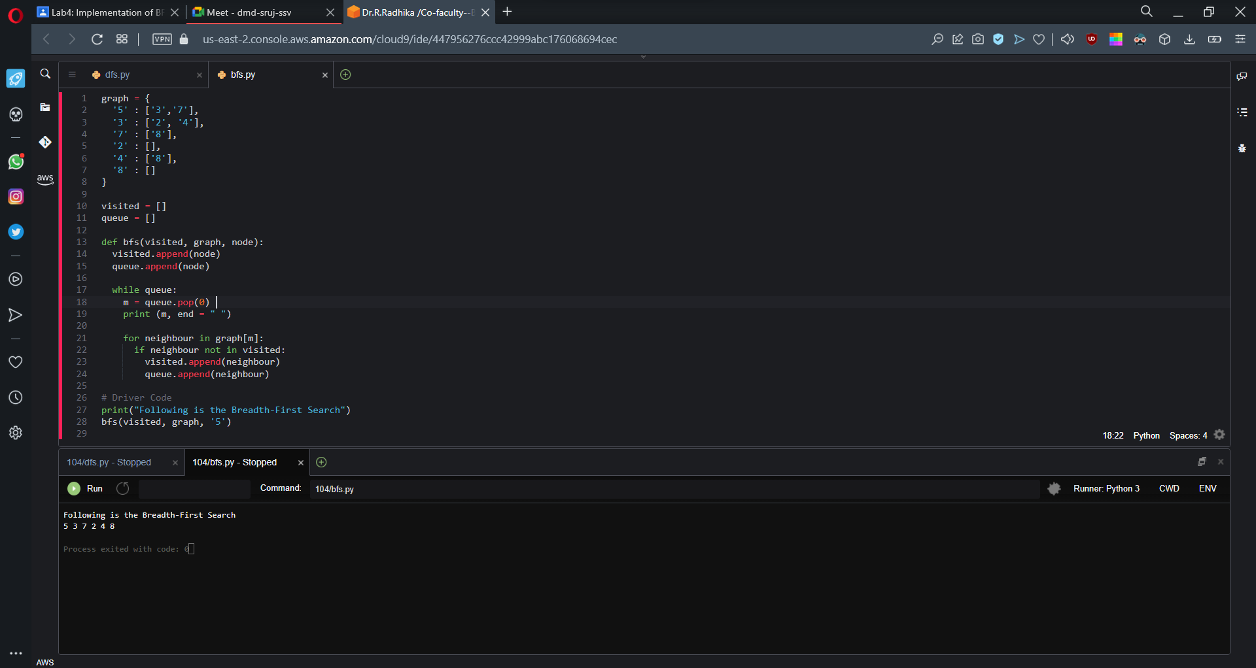

**RESULT:** Hence DFS and BFS are implemented using python in an AWS environment.